**Python/Django Internship Report**

**Personal Details**

Name : Harsh Parmar

College Name : Silver Oak College of Engineering and Tech.

Degree : BE

Semester : 7

Class : CE – F

Roll No. : 22

Github URL : <https://github.com/hpcoding/Python_Django>

**Company Details**

Company Name : Akash Techno labs

External Guide : Akash Padhiyar

Training Duration : 26-05-2021 to 21-06-2021

**Index**

|  |  |  |
| --- | --- | --- |
| **Index** | **Task Detail** | **Page Name** |
| 1 | Simple Registration Form Using Html | 1 |
| 2 | Basic Print Task In Python | 2 |
| 3 | String In Python | 3 |
| 4 | List In Python | 4 |
| 5 | Tuple In Python | 5 |
| 6 | Leap Year In Python | 6 |
| 7 | Odd/Even In Python | 7 |
| 8 | Factorial In Python | 8 |
| 9 | Swapping Values Of Variable in Python | 9 |
| 10 | Functions In Python | 10 |
| 11 | Arithmetic Operators In Python | 11 |
| 12 | Comparison Operators In Python | 12 |
| 13 | Membership Operators In Python | 13 |
| 14 | Identity Operators In Python | 14 |
| 15 | Addition Using Function In Python | 15 |
| 16 | Child/Parent Class In Python | 16 |
| 17 | Area Of Circle In Python | 17 |
| 18 | Finding Interest Program | 18 |
| 19 | Square Of A Number Using Function | 19 |
| 20 | Area Of Rectangle Using Python | 20 |
| 21 | Site Using Django | 21 |
| 22 | Registration Form Using Django | 22 |
| 23 | Get/Post In Django | 23 |
| 24 | Admin Panel in Django | 24 |
| 25 | Showing Details Entered By User At Signup Page | 25 |

1. 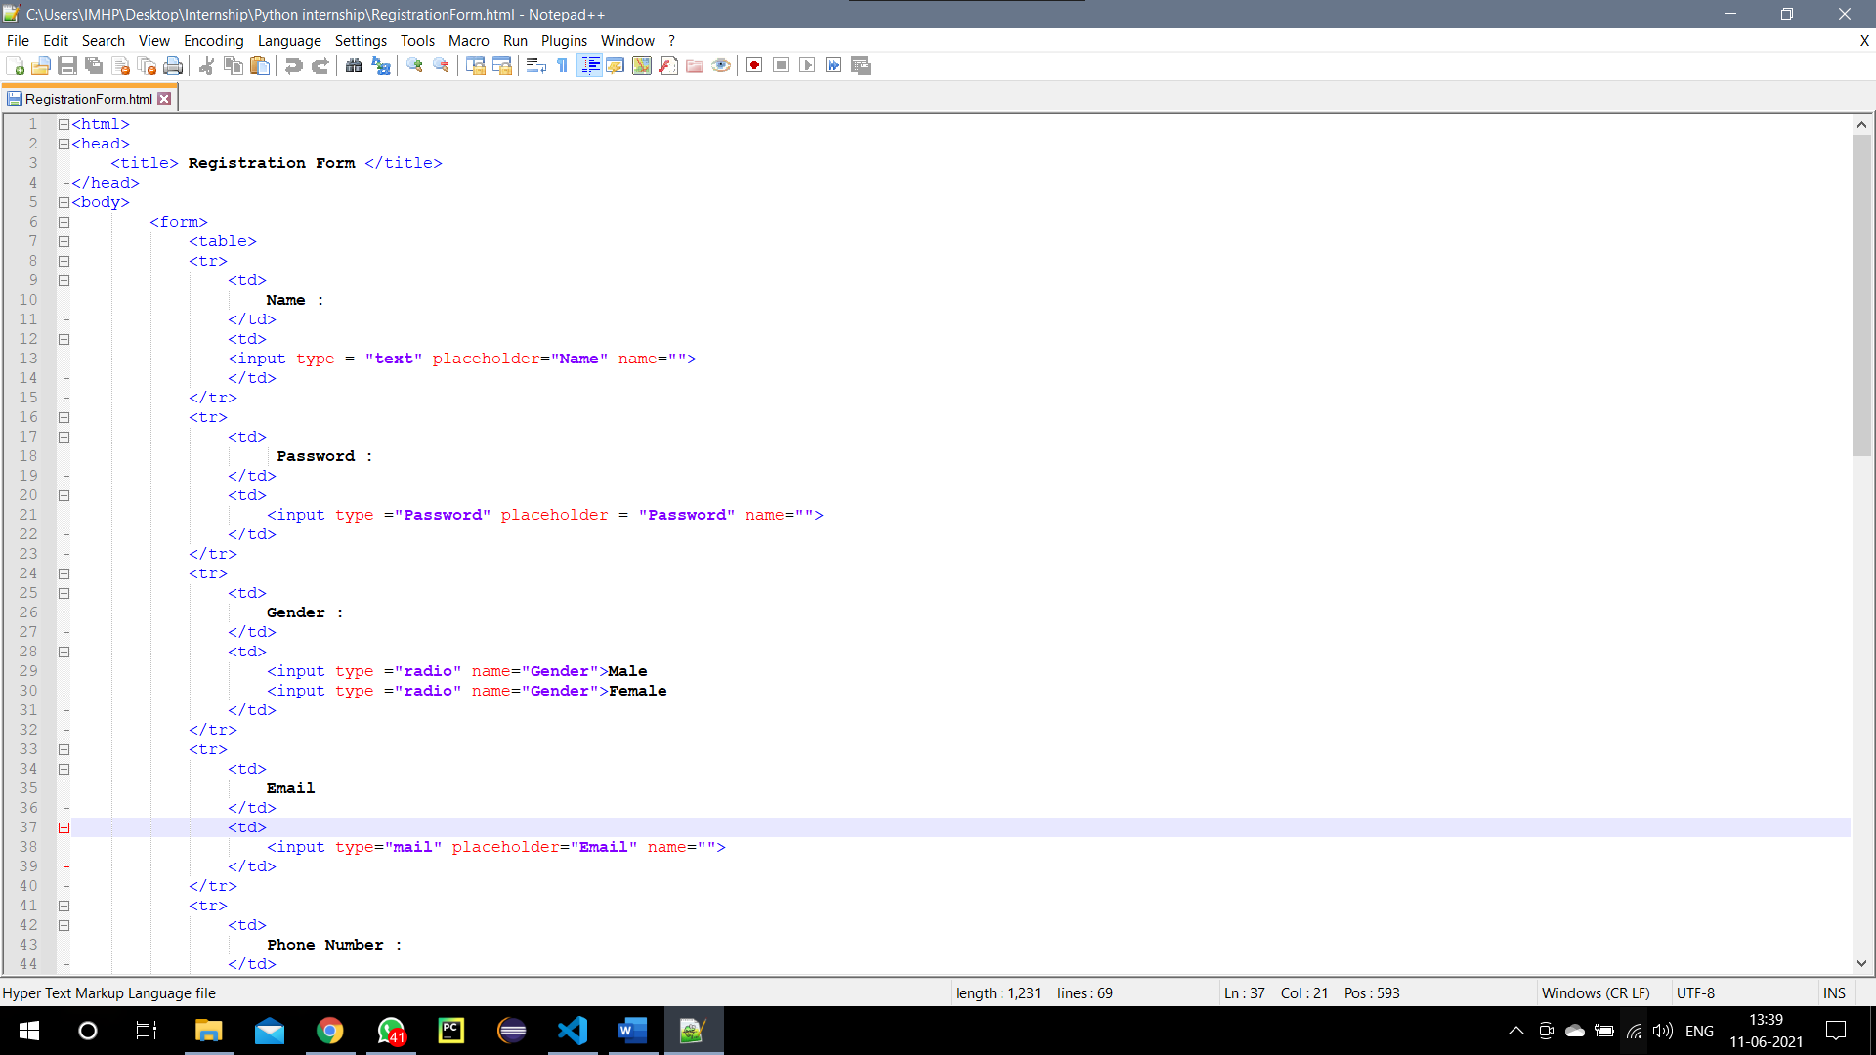**Simple Registration Form Using Html**
2. 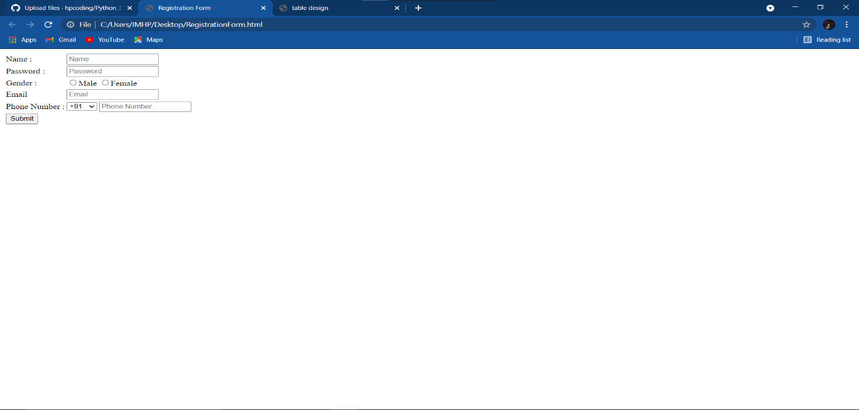Output

**2-** **Basic Print Task In Python**

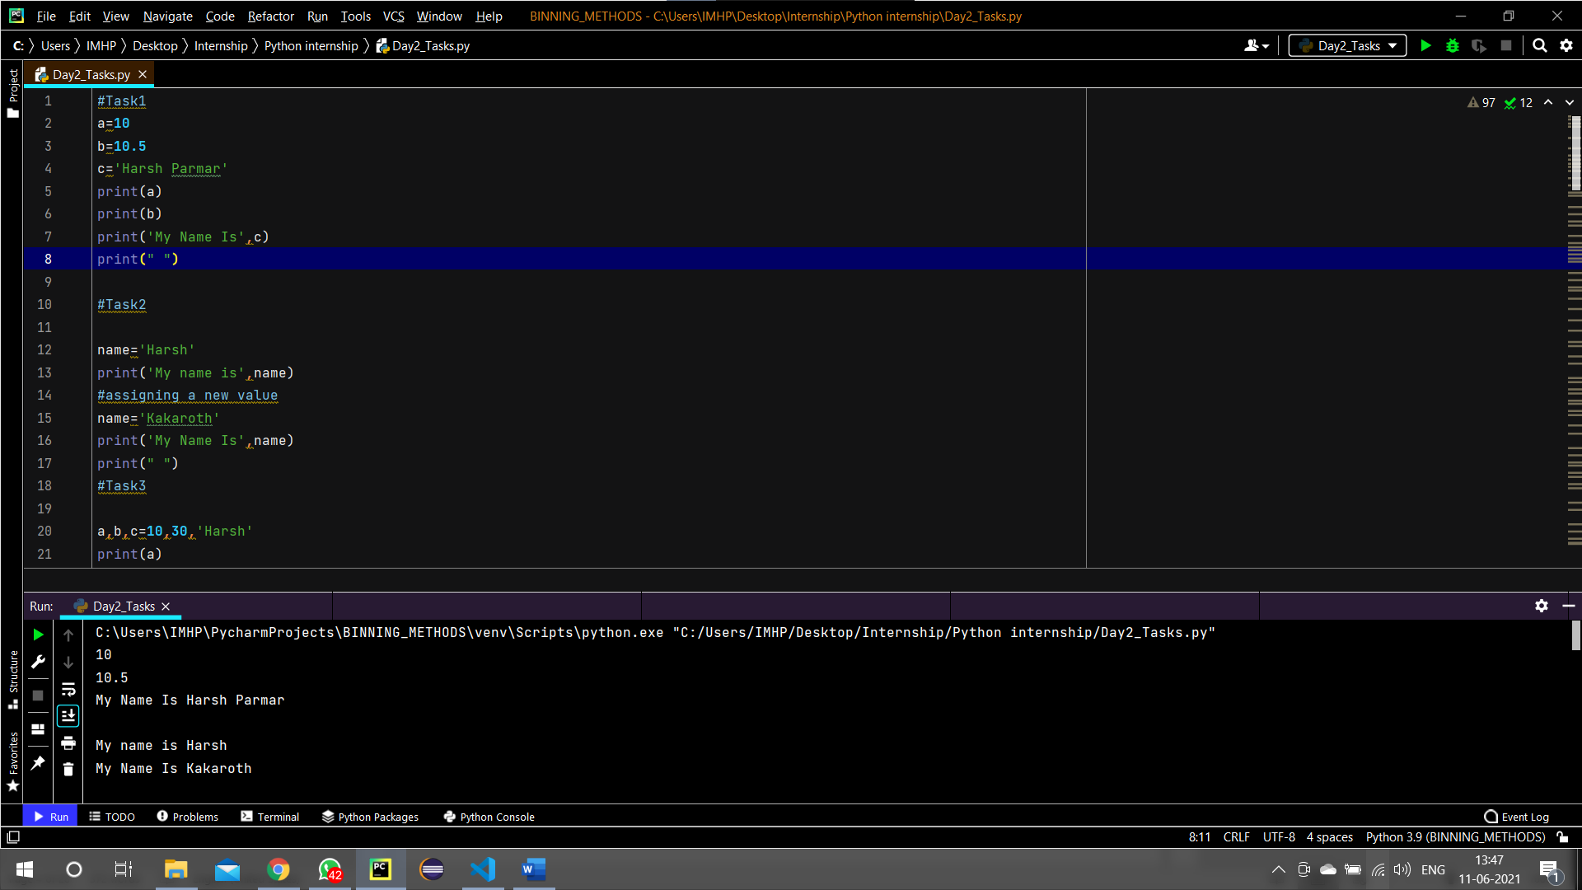

1. **String In Python**

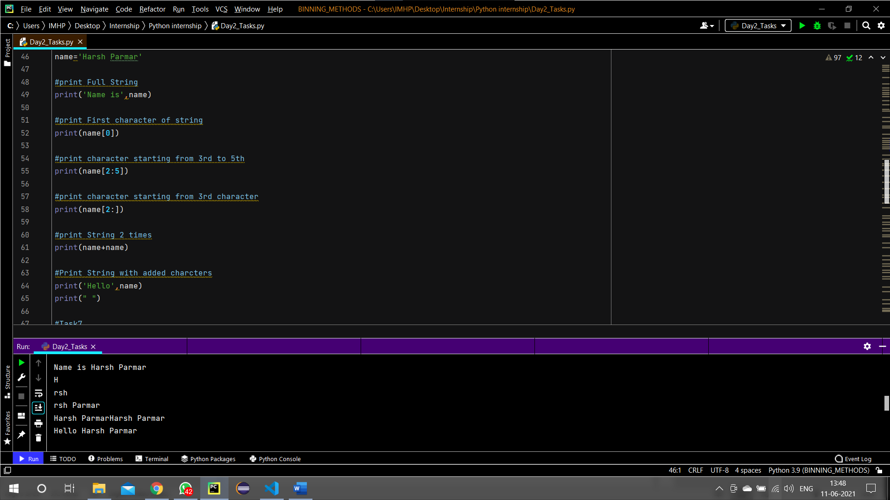

1. **List In Python**

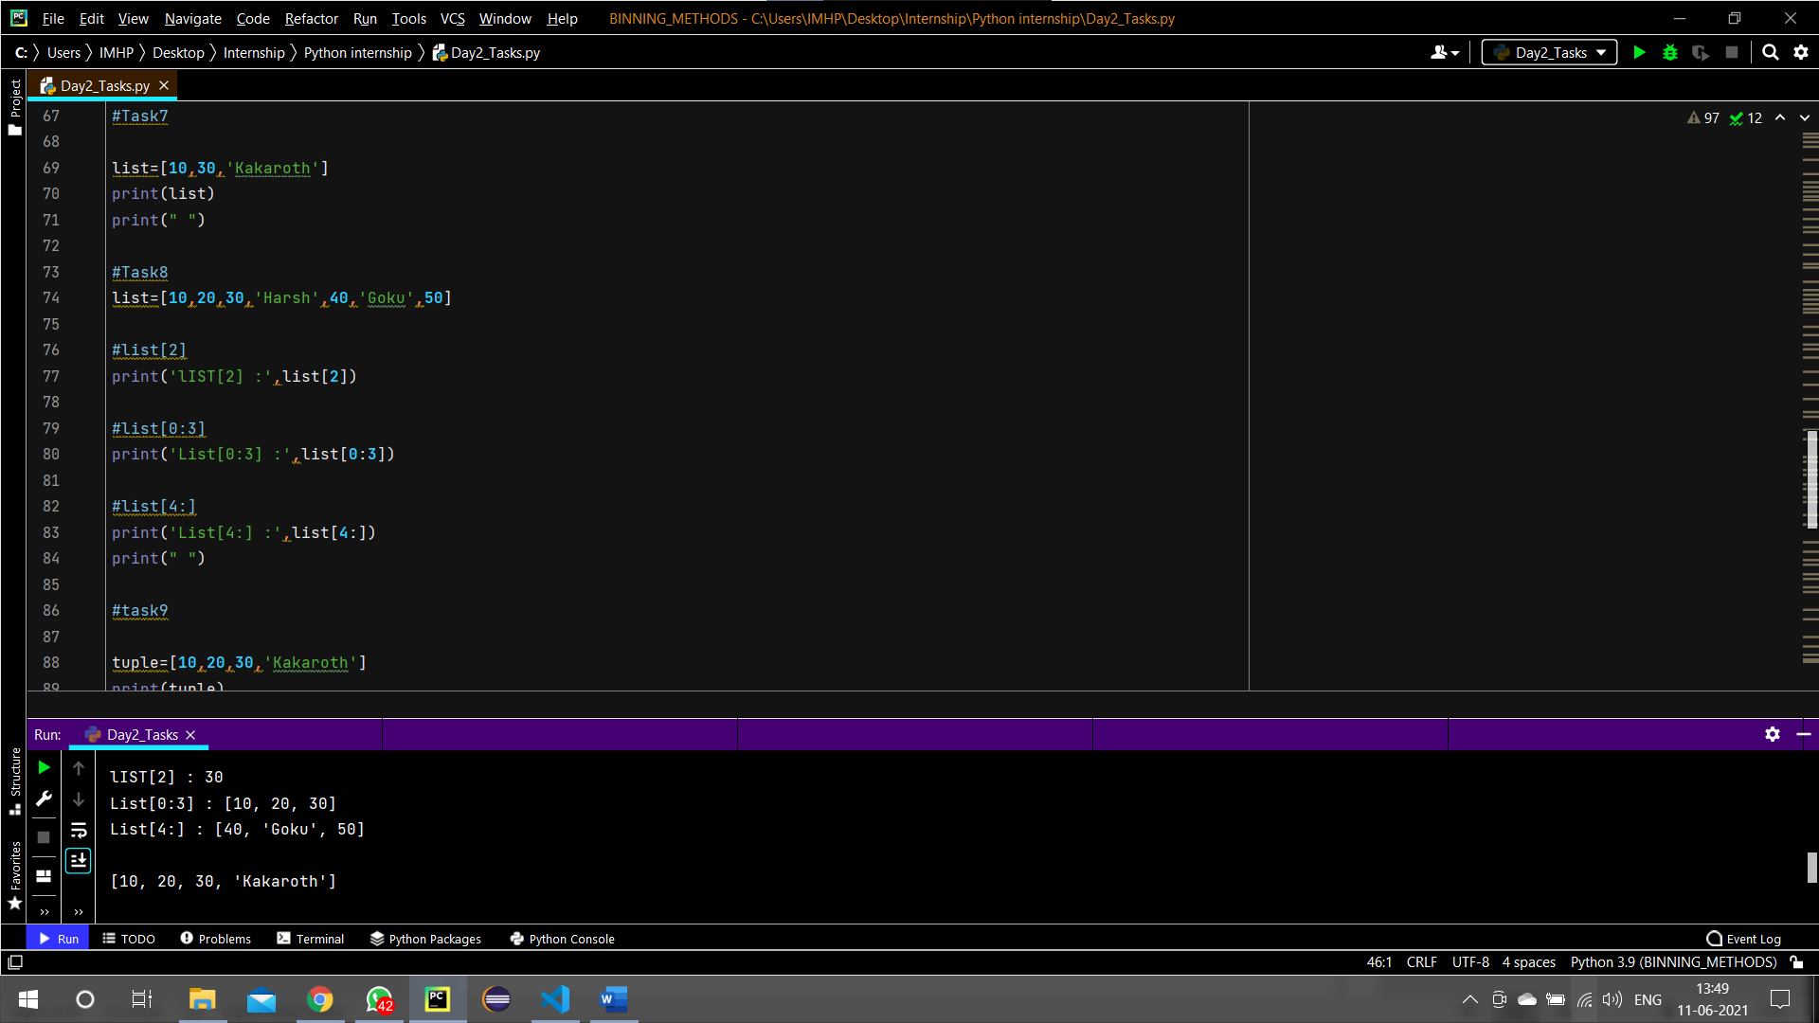

1. **Tuple In Python**

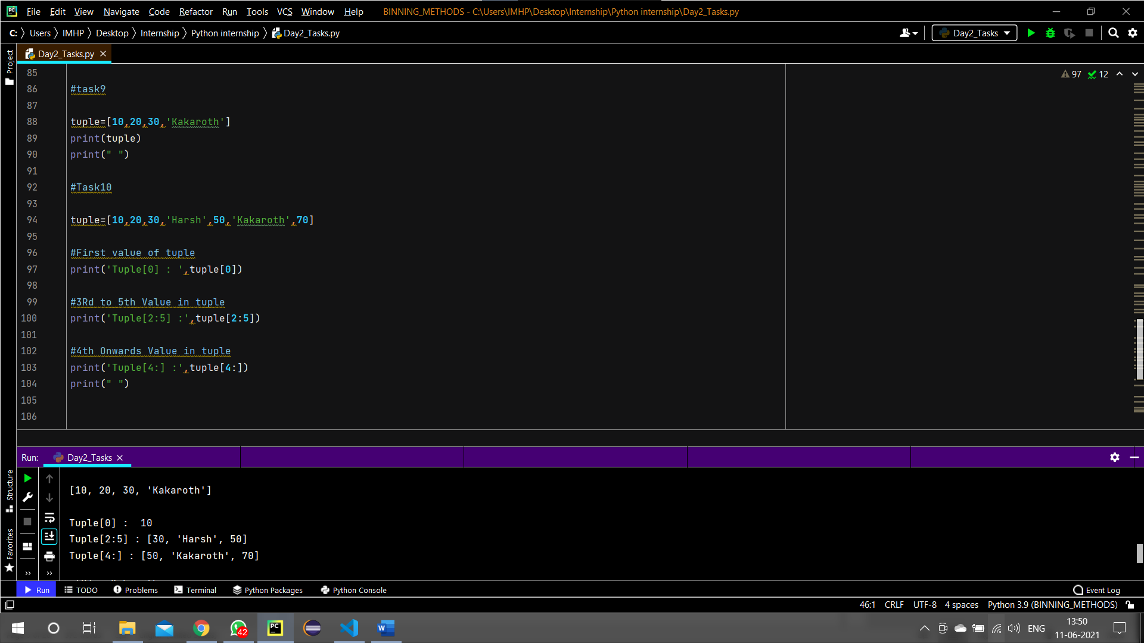

1. **Leap Year In Python**

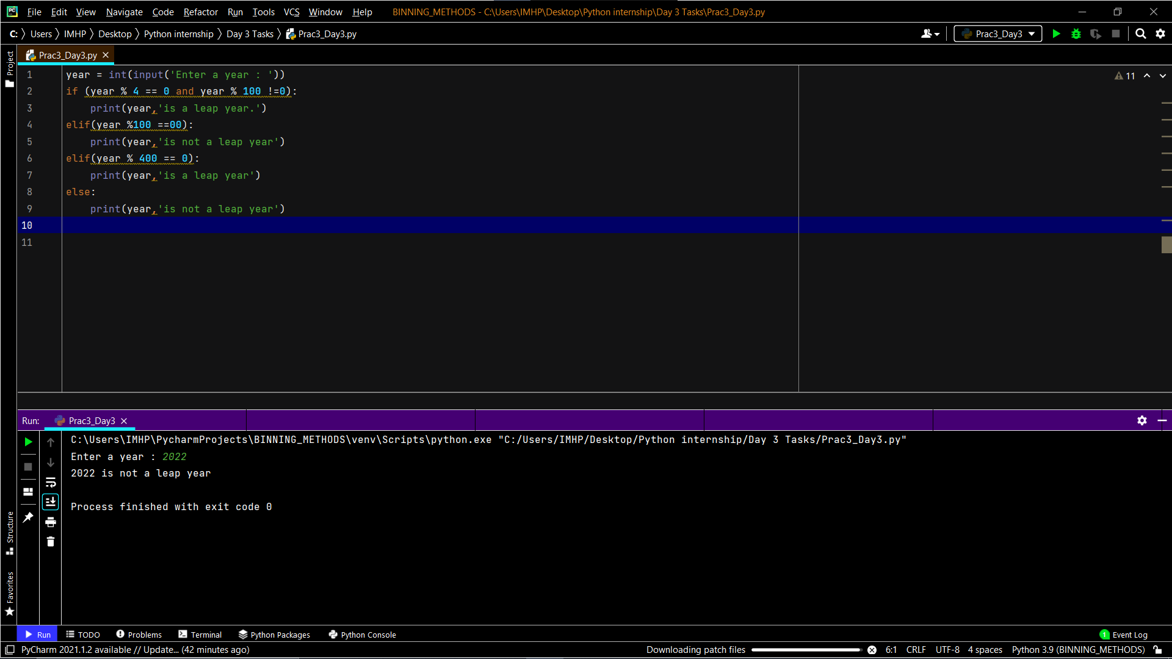

1. **Odd/Even In Python**

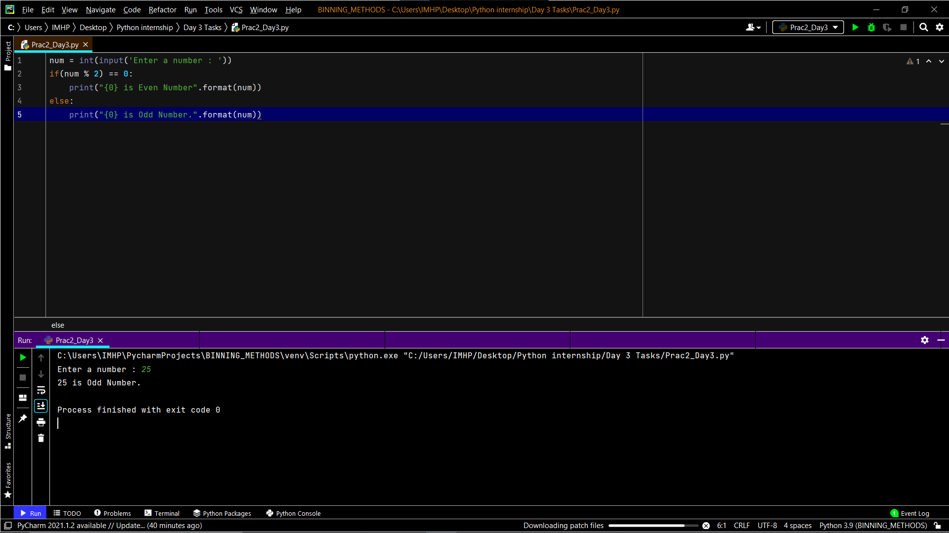

1. **Factorial In Python**

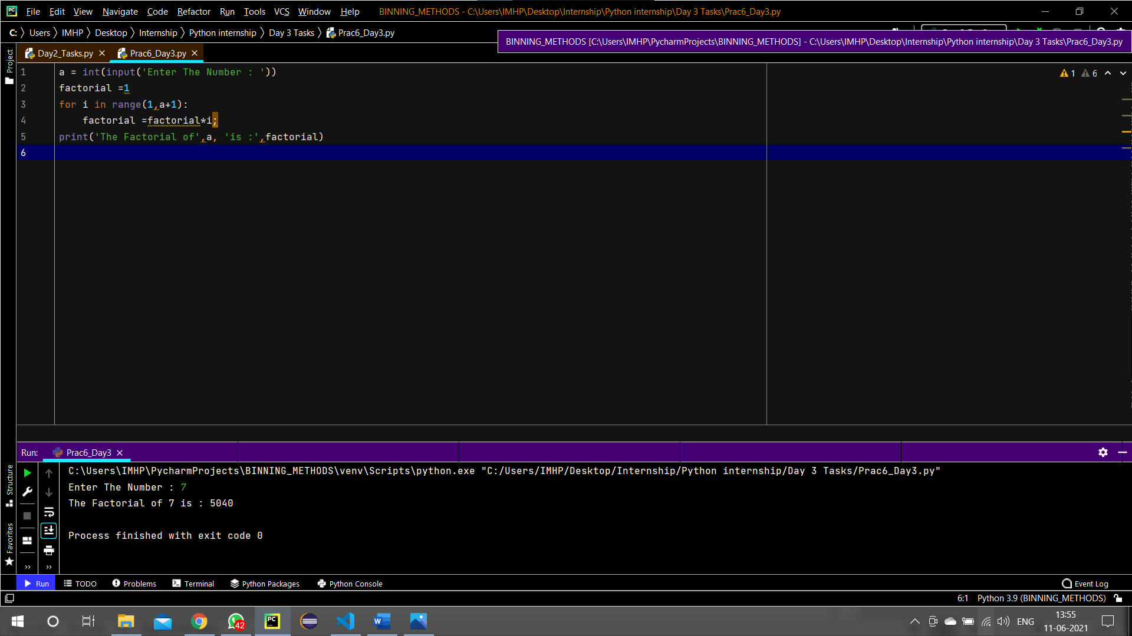

**9-Swapping Values Of Variable in Python**

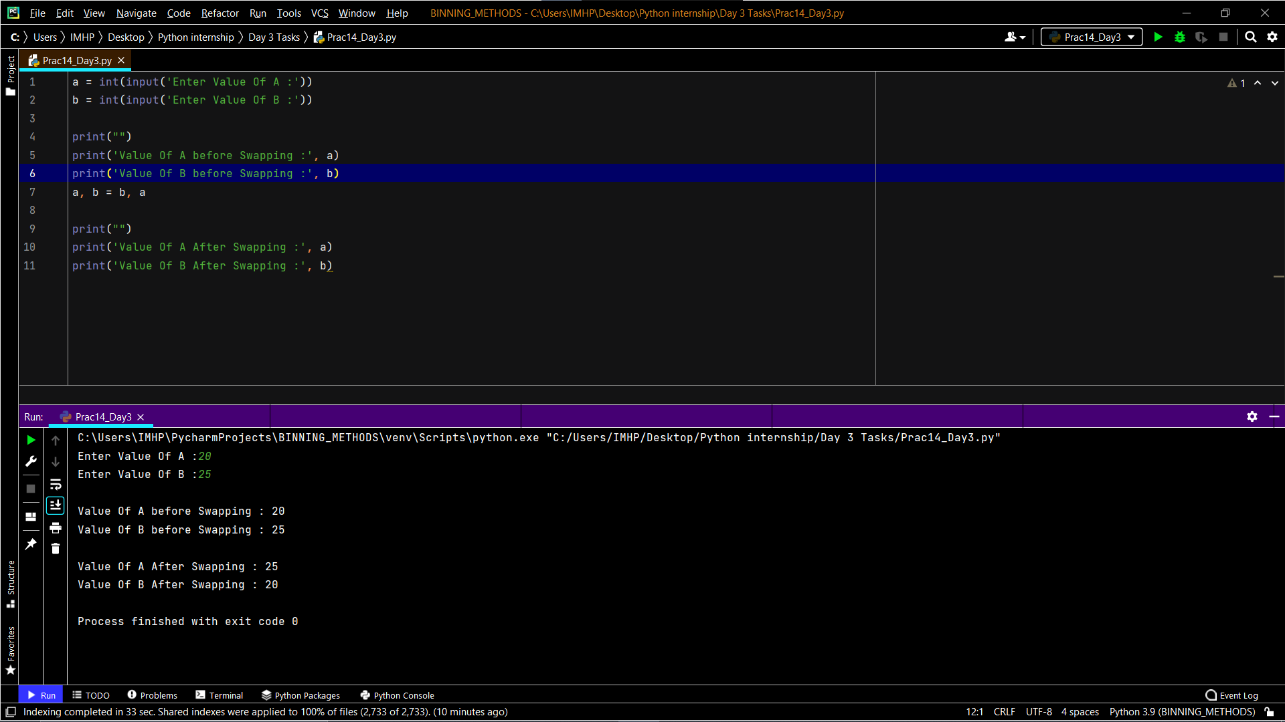

**10 – Functions In Python**

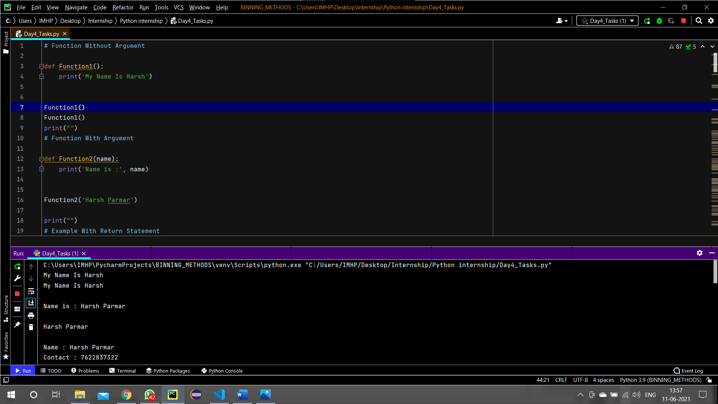

**11 – Arithmetic Operators In Python**

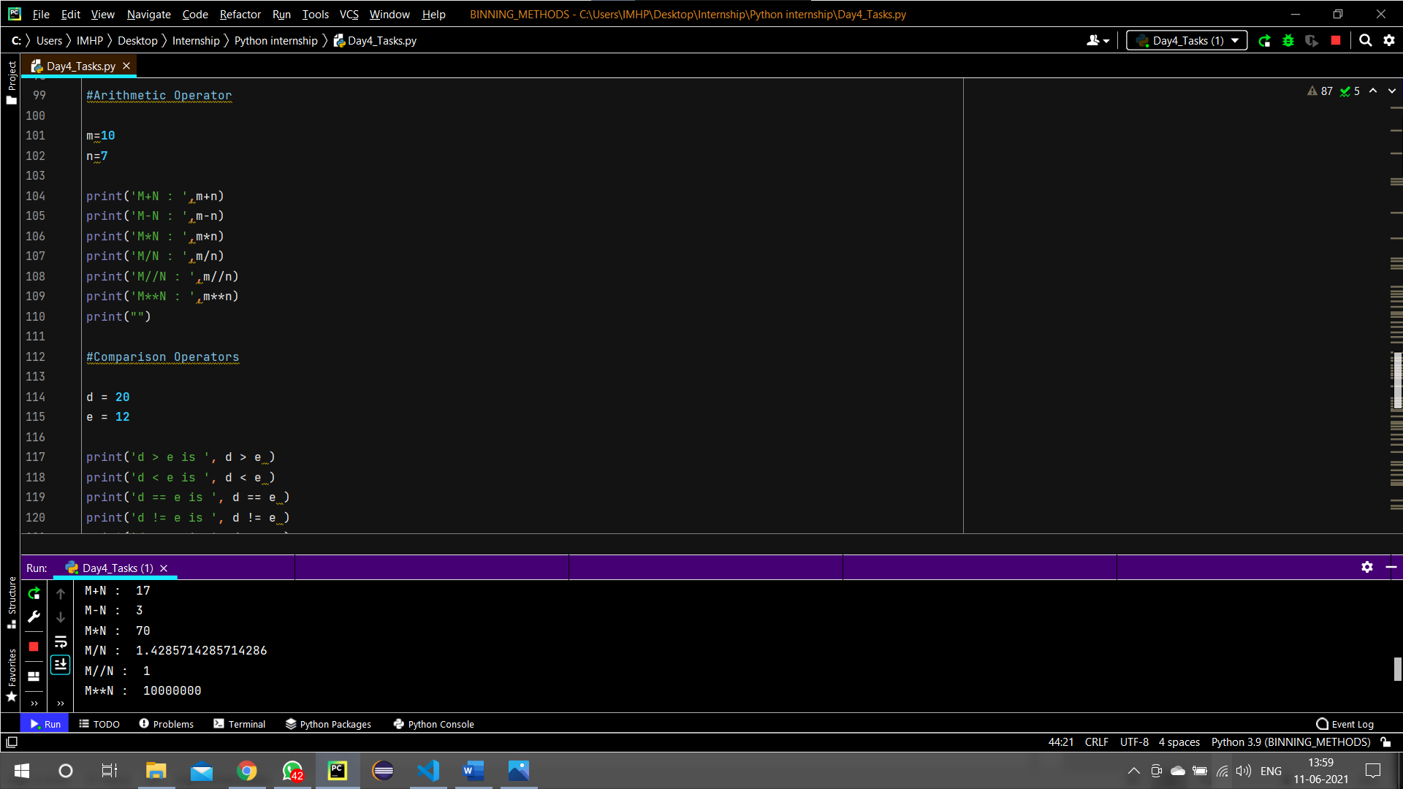

**12 - Comparison Operators In Python**

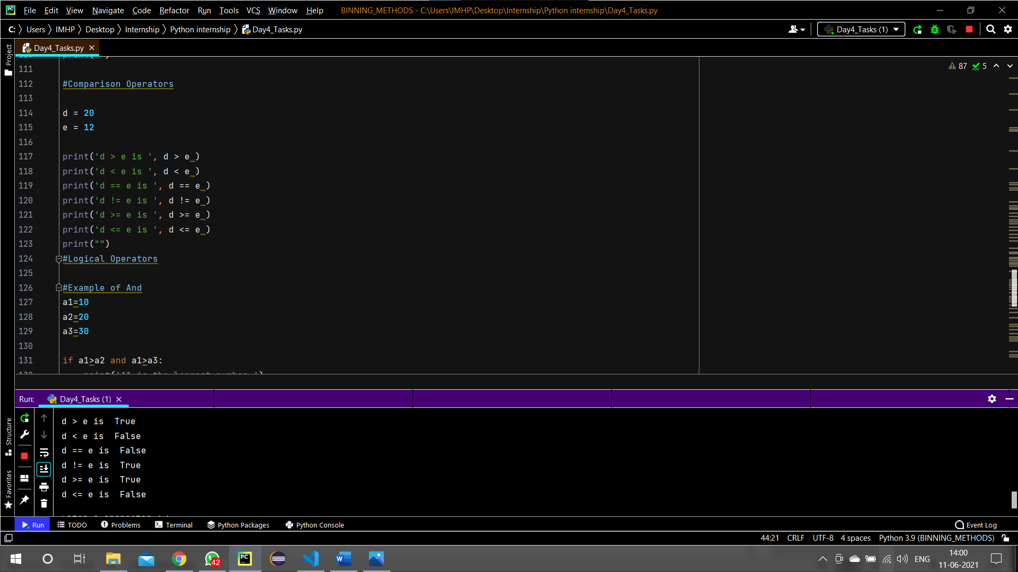

**13 - Membership Operators In Python**

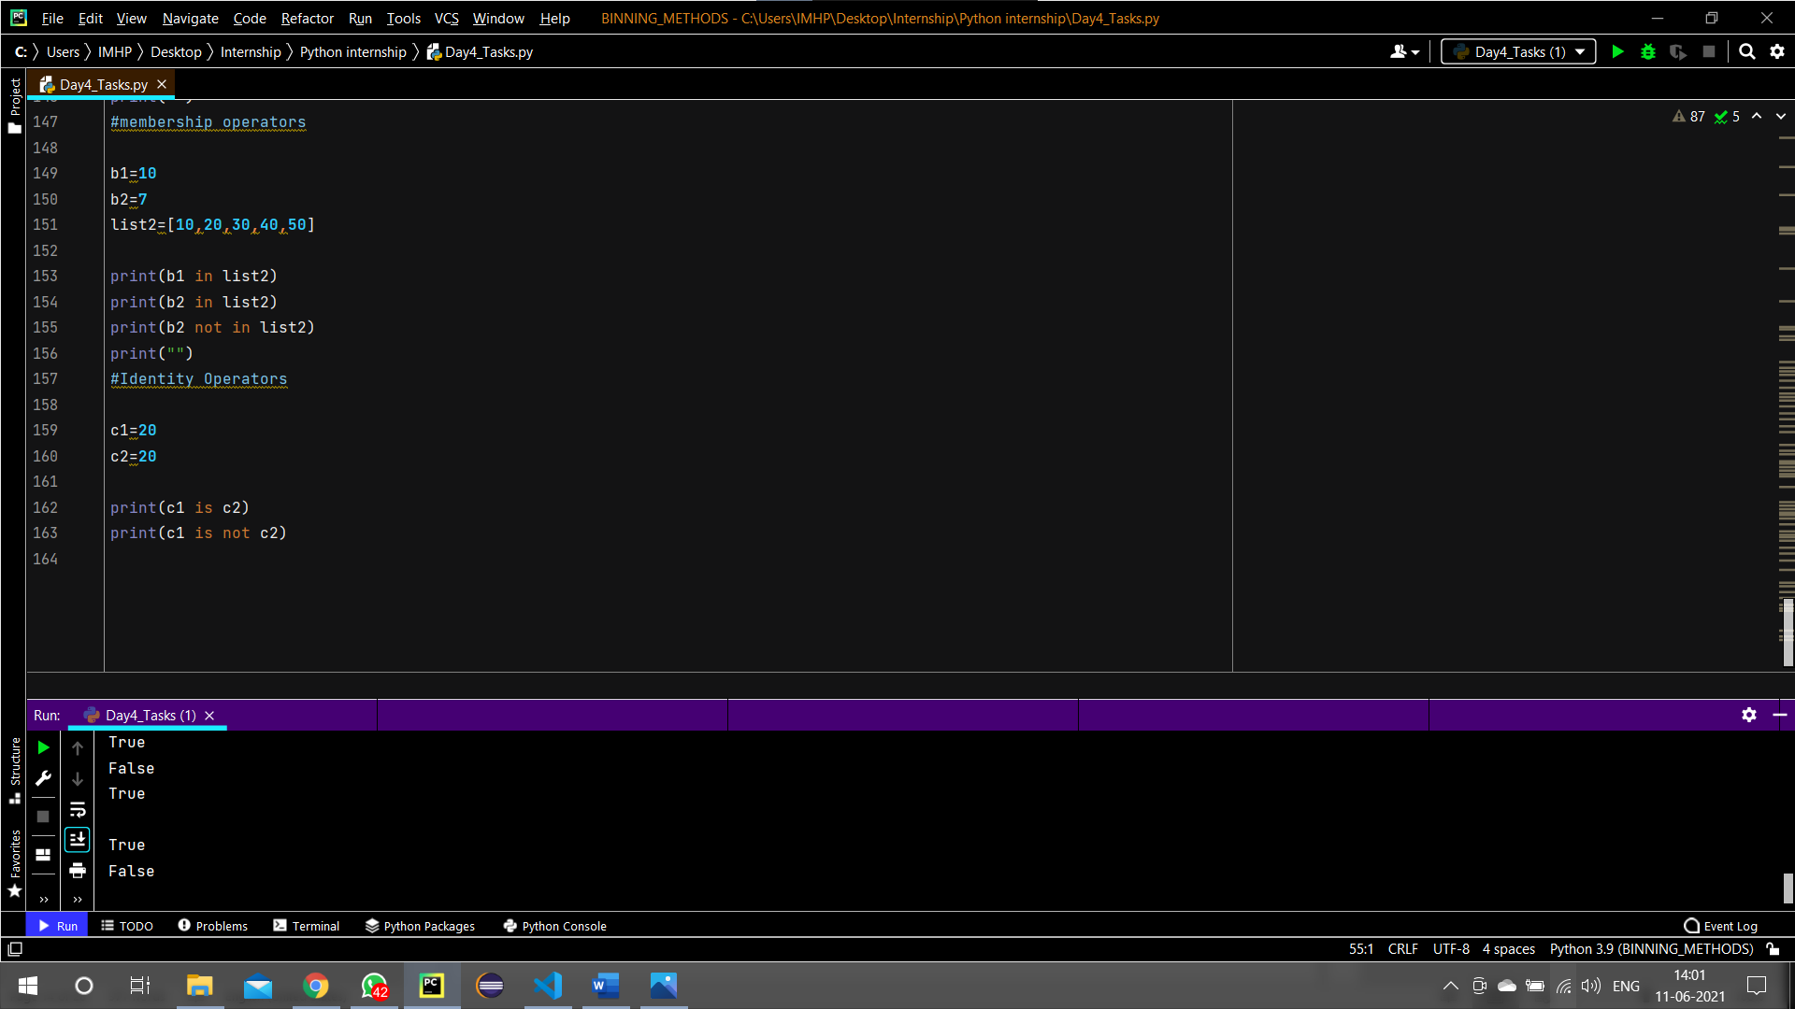

**14 – Identity Operators In Python**

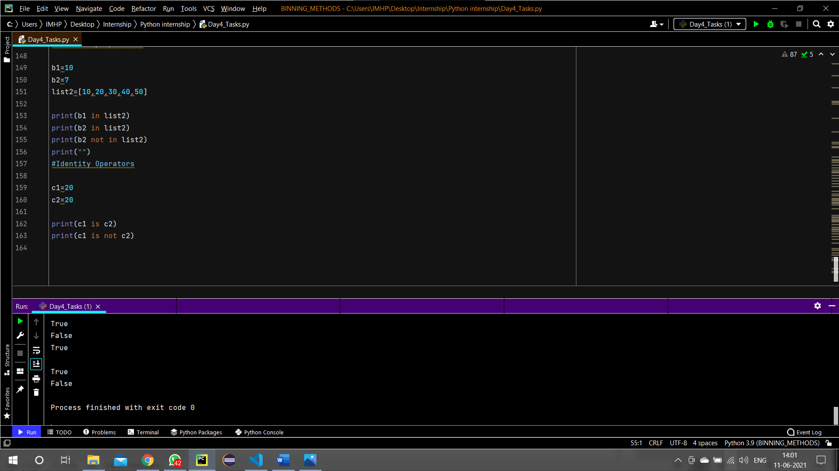

**15 - Addition Using Function In Python**

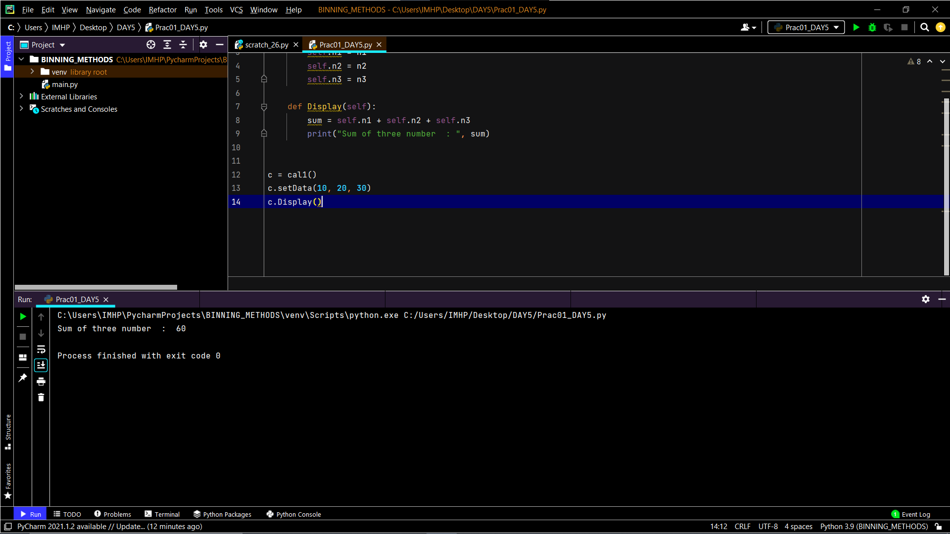

**16 – Child/Parent Class In Python**

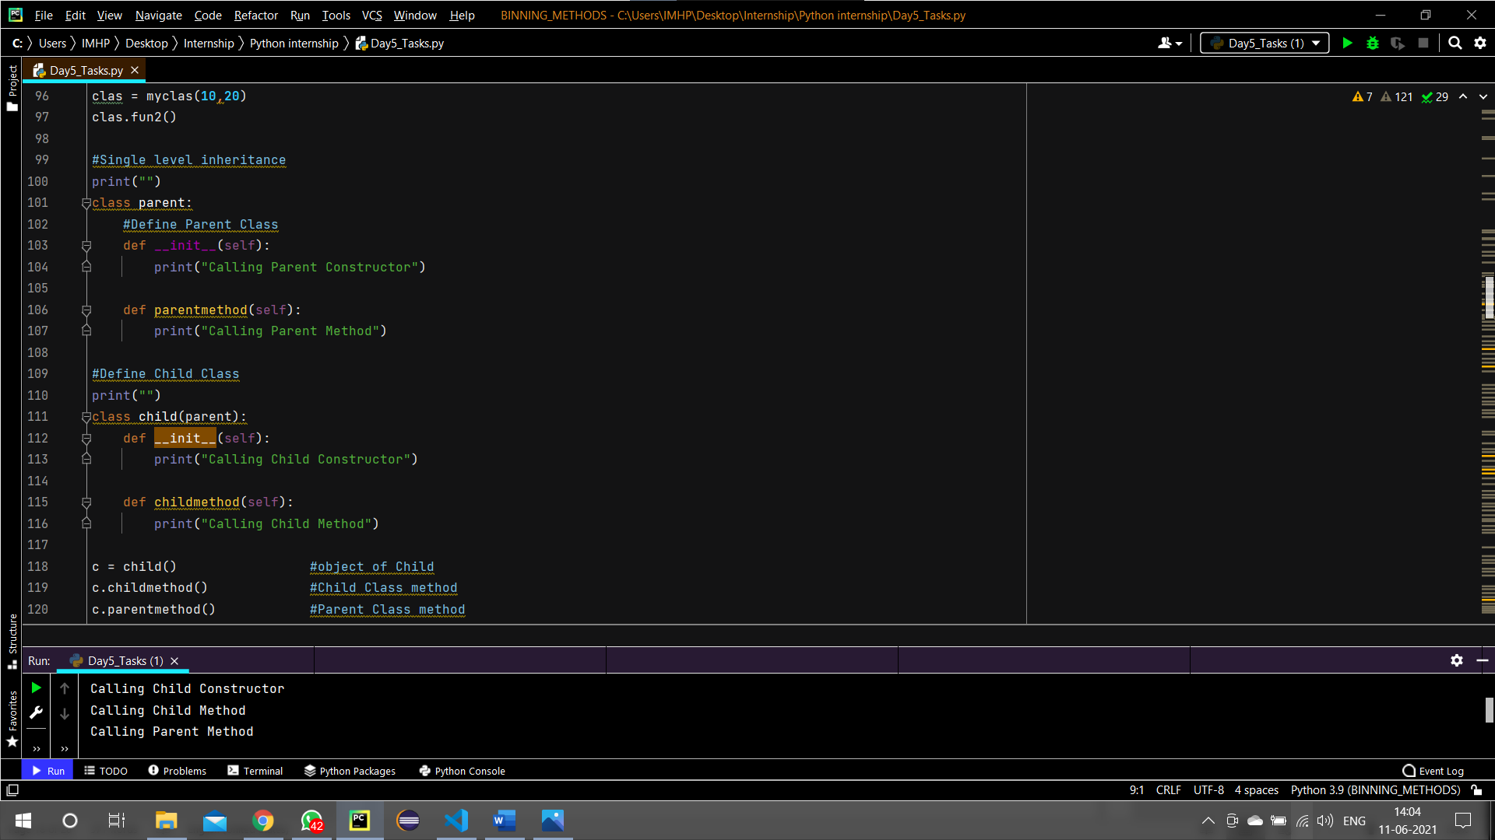

**17 – Area Of Circle In Python**

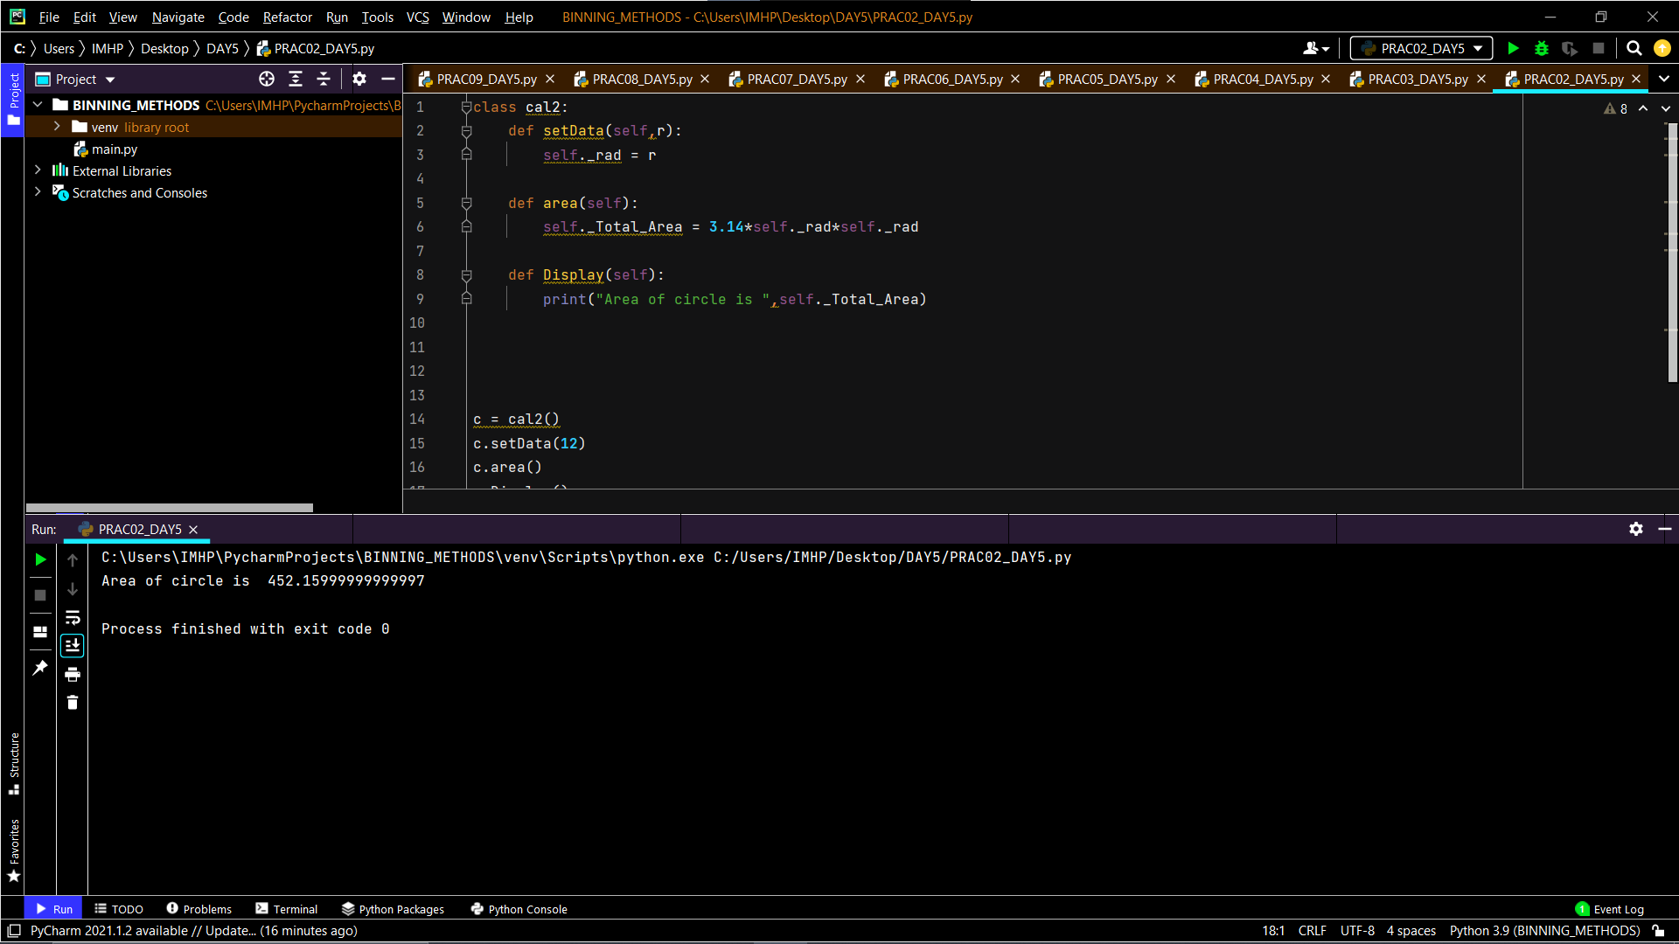

**18 – Finding Interest Program**

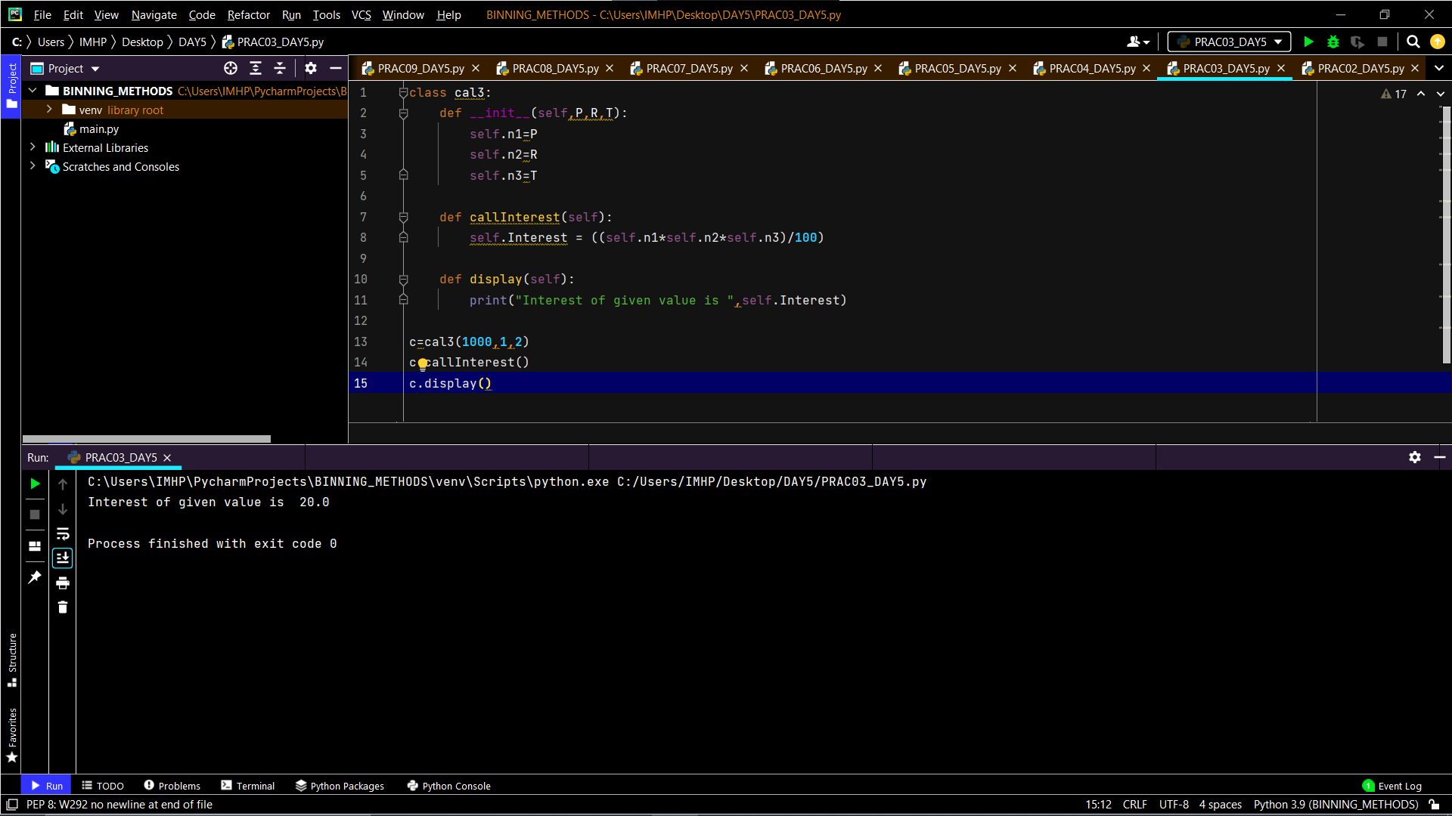

**19 – Square Of A Number Using Function**

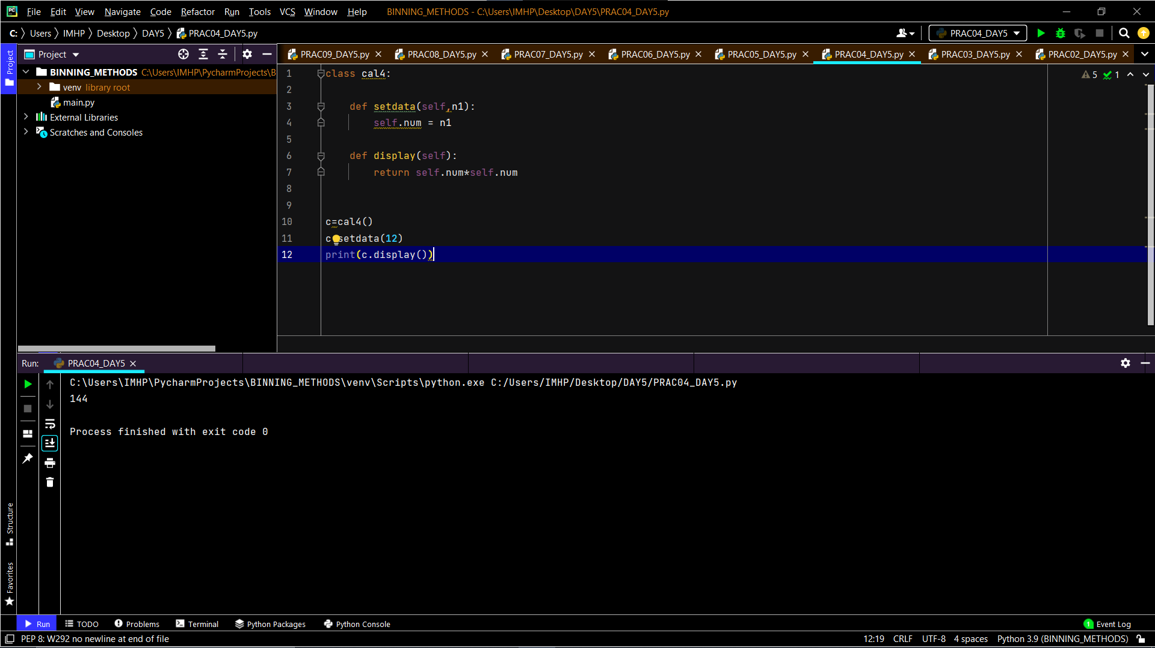

**20 – Area Of Rectangle Using Python**

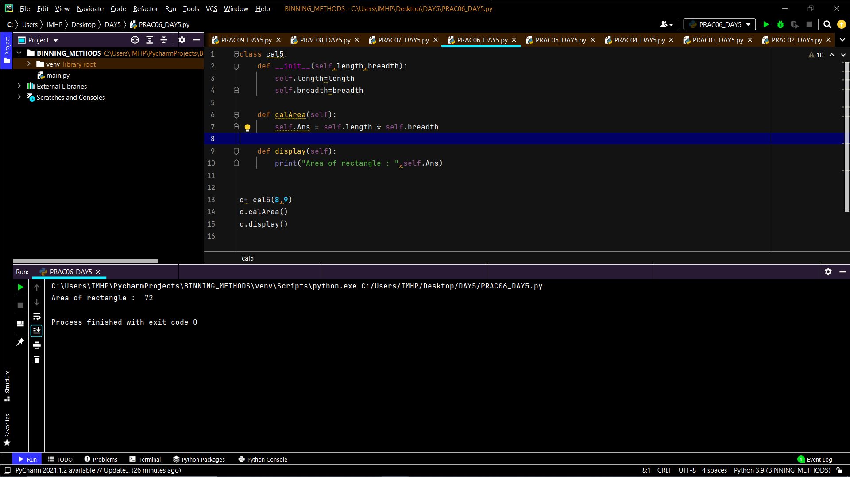

**21 – Site Using Django**

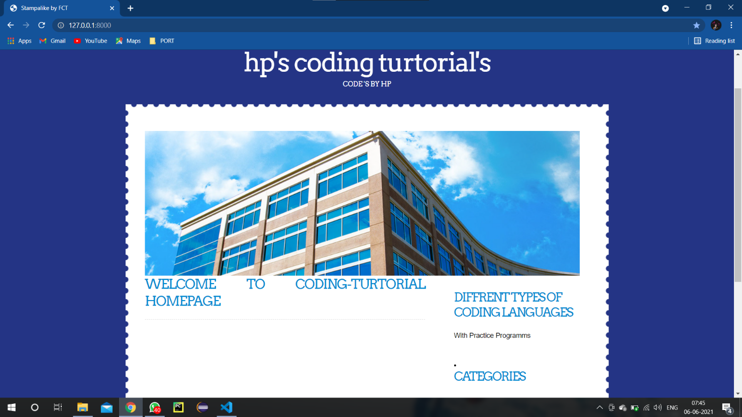

**22 - Registration Form Using Django**

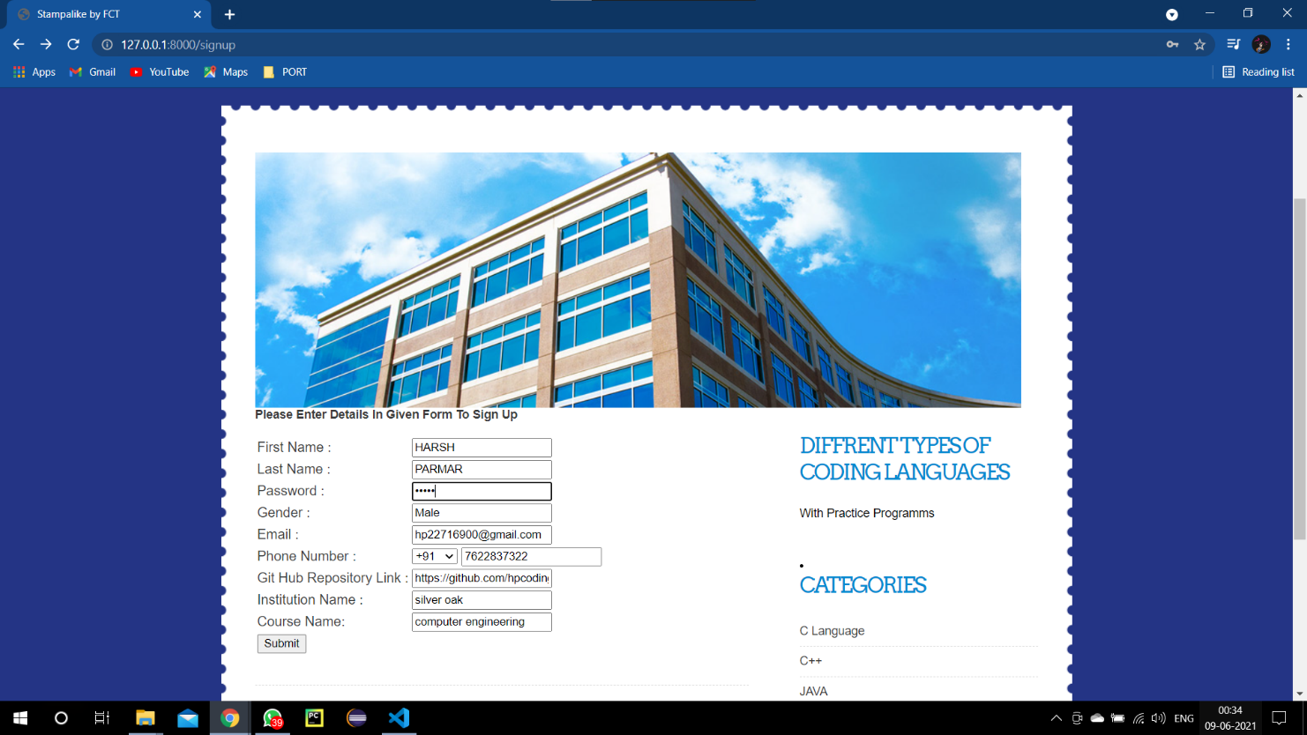

**23 - Get/Post In Django**

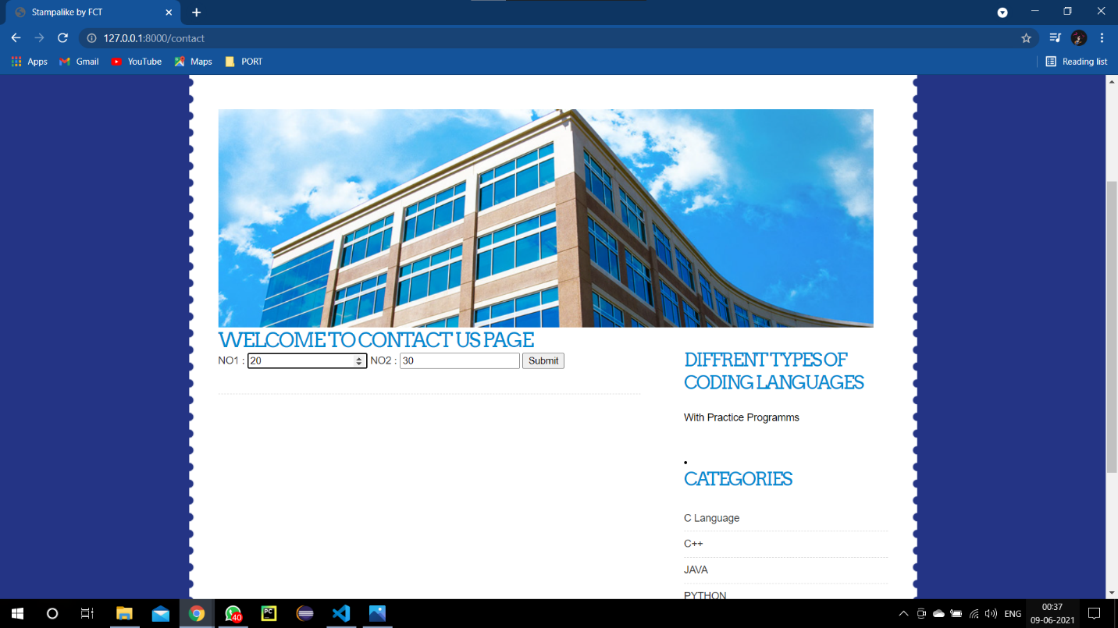

**24 – Admin Panel In Django**

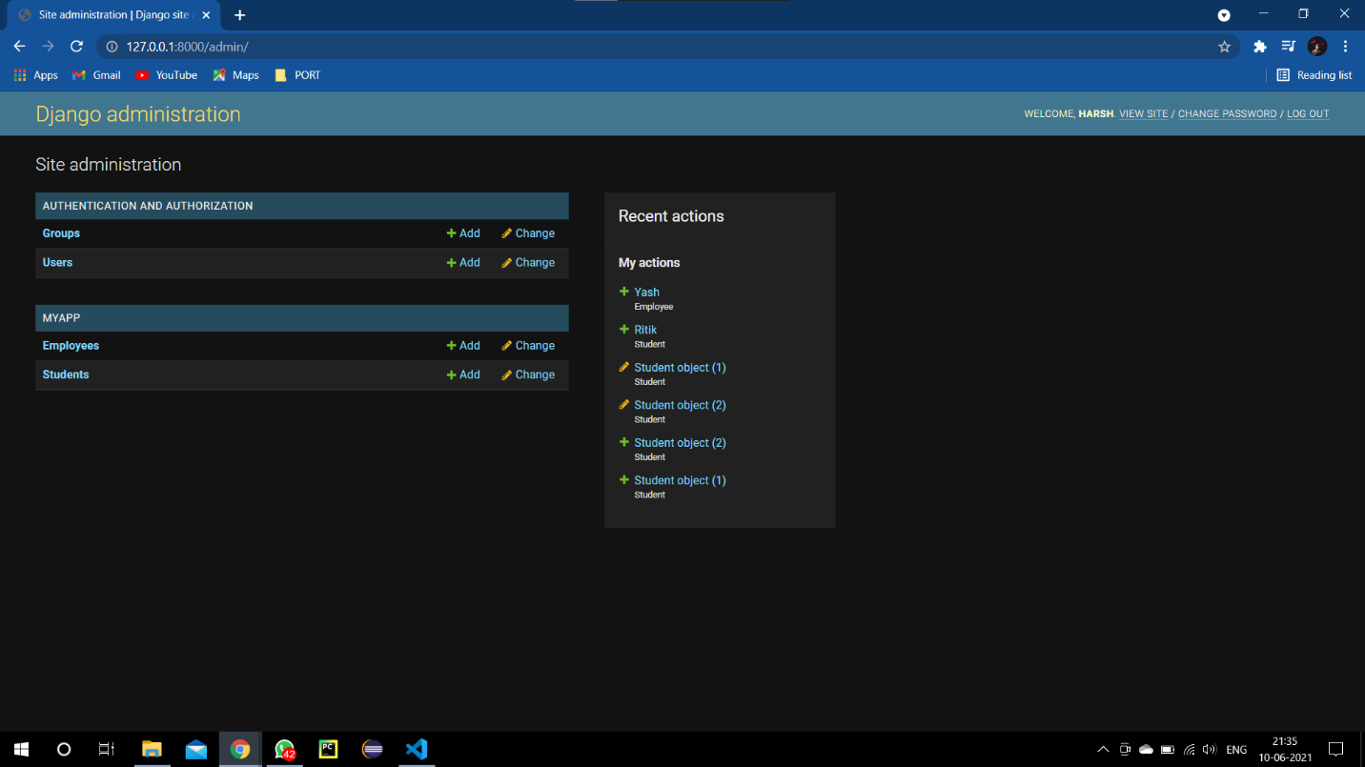

**25 – Showing Details Entered By User At Signup Page**

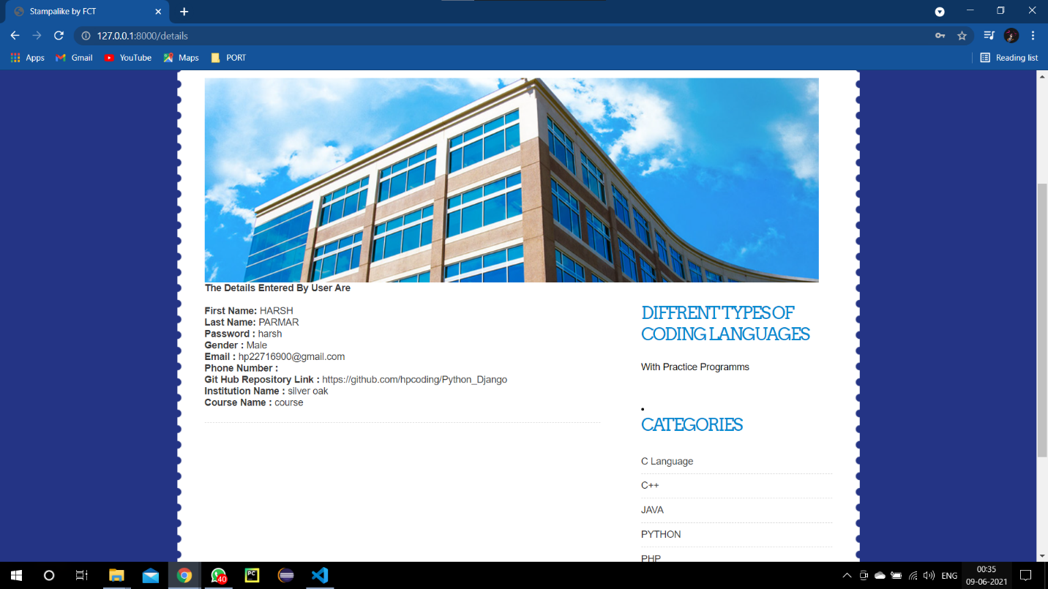

**Information For Certificate**

Name : Harsh Parmar

College Name : Silver Oak College of Engineering and Tech.

Degree : BE

Semester : 7